*Operations and Algebraic Thinking – Patterns (3.0A.9)*

GRADE

3rd

Action Based Learning/MATH



I will use *Math & Movement* Skip Counting Mats and Kinesthetic Learning to identify mathematical patterns.

[](https://www.google.com/imgres?imgurl&imgrefurl=http://www.communityschoolnaples.org/page.cfm?p%3D1072&h=0&w=0&sz=1&tbnid=zs_ylVQYEnR7NM&tbnh=190&tbnw=265&zoom=1&docid=fFDgtVSo9oQ_yM&ei=KpZ_Uo_ABKL-4APB7oGYCQ&ved=0CAEQsCU)

MATERIALS

* *Math & Movement* Hopping Mats, *Math & Movement* Add and Subtract mat, *Math & Movement* Clock Hop*, Math & Movement* Multiplication Hop *and Math & Movement* Multiplication Hop
* Pencils
* Smart Board lessons
* *Math & Movement* Graphic Organizer activity sheet

Vocabulary

* Product: the answer to a multiplication problem
* Factors: the numbers being multiplied in a multiplication problem
* Quotient: the answer to a division problem
* Dividend: the amount that you want to divide up
* Divisor: the number to divide by
* Pattern: Things that are arranged following a rule or rules.



* Have the *Math & Movement* Hop by 3’s, 4’s, 6’s, 7’s, 8’s and 9’s, the *Math & Movement* Add and Subtract mat, the *Math & Movement* Clock Hop mat, and the *Math & Movement* Multiplication mat spread around the room in one large rectangular formation
* Have students stand around the *Math & Movement* Add and Subtract mat.
* “Math is full of patterns and today you are going to use the hopping mats to help find some of these patterns.”
* “What patterns do you see?” Some examples are: all the vertical rows end in the same number…5, 15, 25, 35, etc.)

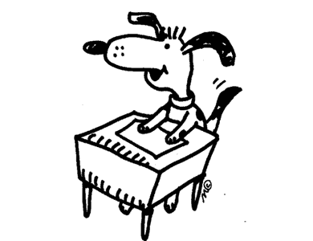

STUDENT WORK TIME

* Have students find a partner and each pair are to use the Math & Movement Pattern Graphic Organizer activity sheet to find patterns on the various mats around the room.
* You will have 8 minutes to complete your graphic organizer and then we will share our patterns.
* Examples of patterns:
  + Hop by 9’s: when you add the two digits of each large number together you get 9
  + Hop by 3’s: the large numbers are odd, then even, then odd, then event
  + Hop by 4’s: every large number is even
  + Add and Subtract mat: in each diagonal row, the tens and ones columns go up and down by one
  + Clock Hop: larger numbers end in either 5 or 0